**UNIT V 8 Application Layer:**

**Domain Name Space, Electronic Mail, File Transfer, Web Documents and HTTP,Network Management System.**

# **DNS**

An application layer protocol defines how the application processes running on different systems, pass the messages to each other.

|  |  |
| --- | --- |
| **Label** | **Description** |
| aero | Airlines and aerospace companies |
| biz | Businesses or firms |
| com | Commercial Organizations |
| coop | Cooperative business Organizations |
| edu | Educational institutions |
| gov | Government institutions |
| info | Information service providers |
| int | International Organizations |
| mil | Military groups |
| museum | Museum & other nonprofit organizations |
| name | Personal names |
| net | Network Support centers |
| org | Nonprofit Organizations |
| pro | Professional individual Organizations |

**DNS stands for Domain Name System.**

* DNS is a directory service that provides a mapping between the name of a host on the network and its numerical address.
* DNS is required for the functioning of the internet.
* Each node in a tree has a domain name, and a full domain name is a sequence of symbols specified by dots.
* DNS is a service that translates the domain name into IP addresses. This allows the users of networks to utilize user-friendly names when looking for other hosts instead of remembering the IP addresses.
* For example, suppose the FTP site at EduSoft had an IP address of 132.147.165.50, most people would reach this site by specifying ftp.EduSoft.com. Therefore, the domain name is more reliable than IP address.

DNS is a TCP/IP protocol used on different platforms. The domain name space is divided into three different sections: generic domains, country domains, and inverse domain.

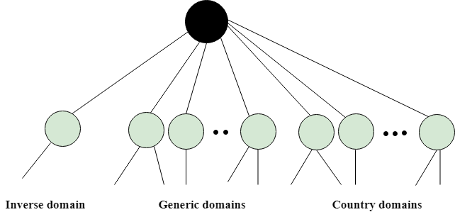

## Generic Domains

* It defines the registered hosts according to their generic behavior.
* Each node in a tree defines the domain name, which is an index to the DNS database.
* It uses three-character labels, and these labels describe the organization type.

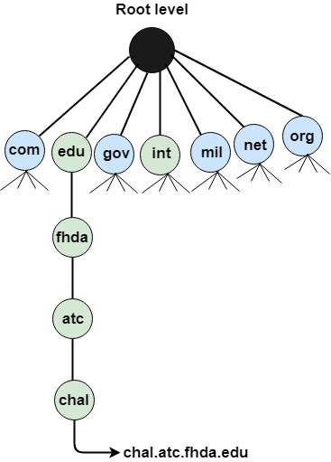

## Country Domain

The format of country domain is same as a generic domain, but it uses two-character country abbreviations (e.g., us for the United States) in place of three character organizational abbreviations.

## Inverse Domain

The inverse domain is used for mapping an address to a name. When the server has received a request from the client, and the server contains the files of only authorized clients. To determine whether the client is on the authorized list or not, it sends a query to the DNS server and ask for mapping an address to the name.

## Working of DNS

* DNS is a client/server network communication protocol. DNS clients send requests to the. server while DNS servers send responses to the client.
* Client requests contain a name which is converted into an IP address known as a forward DNS lookups while requests containing an IP address which is converted into a name known as reverse DNS lookups.
* DNS implements a distributed database to store the name of all the hosts available on the internet.
* If a client like a web browser sends a request containing a hostname, then a piece of software such as **DNS resolver** sends a request to the DNS server to obtain the IP address of a hostname. If DNS server does not contain the IP address associated with a hostname, then it forwards the request to another DNS server. If IP address has arrived at the resolver, which in turn completes the request over the internet protocol.

**Introduction:**

**Electronic mail (e-mail)** is a computer-based program that allows users to send and receive messages. E-mail is the electronic version of a letter, but with time and flexibility advantages. While a letter can take anywhere from a week to a couple of months to reach its intended destination, an e-mail is sent virtually almost instantly.

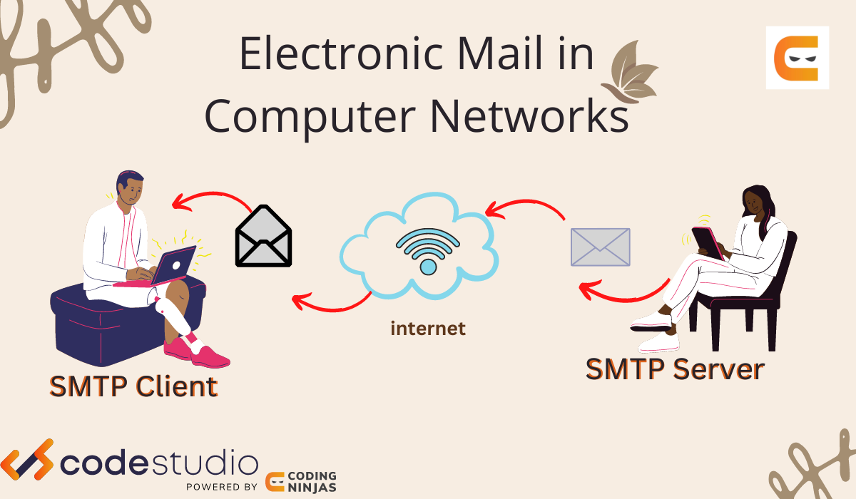

Messages in the mail contain not just text but also photos, audio, and video data. A person sending an e-mail is a**sender**, and the person receiving it is the **recipient**.

**What is Electronic Mail in Computer Networks?**

Electronic mail is [computer networks](https://www.codingninjas.com/studio/library/introduction-to-computer-networks)one of the most well-known network services. Electronic mail is a computer-based service that allows users to communicate with one another by exchanging messages.  Email information is transmitted via email servers and uses a variety of TCP/IP protocols. For example, the simple mail transfer protocol (SMTP) is a protocol that is used to send messages. Similarly, IMAP or POP receives messages from a mail server.

Talk to our counsellor

**Features Of Electronic Mail**

* **Spontaneity:** In a couple of seconds, you may send a message to anybody on the globe.
* **Asynchronous:** You may send the e-mail and let the recipient view it at their leisure.
* Attachments of data, pictures, or music, frequently in compressed forms, can be delivered as an e-mail to a person anywhere in the world.
* Addresses can be stored in an address book and retrieved instantly.
* Through an e-mail, a user can transfer multiple copies of a message to various individuals.

**Services offered by Electronic Mail**

* **Composition:**Creating messages and responses is referred to as composition.
* **Transfer:**Sending mail from the sender to the receiver is known as a transfer.
* **Reporting:**Mail delivery confirmation is known as reporting. It allows users to see if   
  their mail has been delivered, misplaced, or rejected.
* **Displaying:**It refers to presenting messages so that the user can understand them.
* **Disposition:**This stage concerns the recipient's actions after receiving mail, such as saving it, deleting it before reading it, or after reading it.

**Components Of Electronic Mail**

The following are the essential components of an e-mail system:

1. User Agent (UA)
2. Message Transfer Agent (MTA)
3. Message Access Agent

**User Agent (UA)**

The User-Agent is a simple software that sends and receives mail. It is also known as a mail reader. It supports a wide range of instructions for sending, receiving, and replying to messages and manipulating mailboxes.

Some of the services supplied by the User-Agent are listed below:

* Reading a Message
* Sending a reply to a Message
* Message Composition
* Forwarding a Message
* Handling the Message

**Message Transfer Agent**

The Message Transfer Agent manages the actual e-mail transfer operation (MTA). Simple Mail Transfer Protocol sends messages from one MTA to another. A system must have a client MTA and a system MTA to send an e-mail. If the recipients are connected to the same computer, it sends mail to their mailboxes. If the destination mailbox is on another computer, it sends mail to the receiver's MTA.

**Message Access Agent**

The Simple Mail Transfer Protocol is used for the first and second stages of e-mail delivery.

The pull protocol is mainly required at the third stage of e-mail delivery, and the message access agent is used at this point.

[POP](https://www.codingninjas.com/studio/library/pop-protocol) and IMAP4 are the two protocols used to access messages.

**Architecture of Electronic Mail**

**First Scenario**

In the first scenario, two user agents are required. The sender and recipient of the e-mail share the same machine directly connected to the server.

For example, let us consider two user agents, Ninja1 and Ninja2. When Ninja1 sends an e-mail to Ninja2, the user agent (UA) programme is used to prepare the message. Following that, this e-mail gets saved in the Ninja2 inbox.

**Second Scenario**

In this case, the sender and recipient of an e-mail are essentially users on two different machines over the [internet](https://www.codingninjas.com/Electronic%20Mail%20In%20Computer%20Networks). User-Agents and Message Transfer Agents(MTA) are required in this scenario.

Take, for example, two user agents (Ninja1 and Ninja2), as illustrated in the diagram. When Ninja1 sends an e-mail to Ninja2, the user agent (UA) and message transfer agents (MTAs) programmes prepare the e-mail for transmission over the internet. Following that, this e-mail gets stored in Ninja2's inbox.

**Third Scenario**

The sender is connected to the system by a point-to-point WAN, which can be a dial-up modem or a cable modem in this case. On the other hand, the receiver is directly attached to the system, as it was in the second scenario.

The sender also needs a User agent (UA) to prepare the message in this situation. After preparing the statement, the sender delivers it over LAN or WAN via a pair of MTAs.

**Fourth Scenario**

In this scenario, the recipient is linked to the mail server via WAN or LAN. When the message arrives, the recipient must retrieve it, which needs additional client/server agents. This scenario requires two user agents (UAs), two pairs of message transfer agents (MTAs), and a couple of message access agents (MAAs).

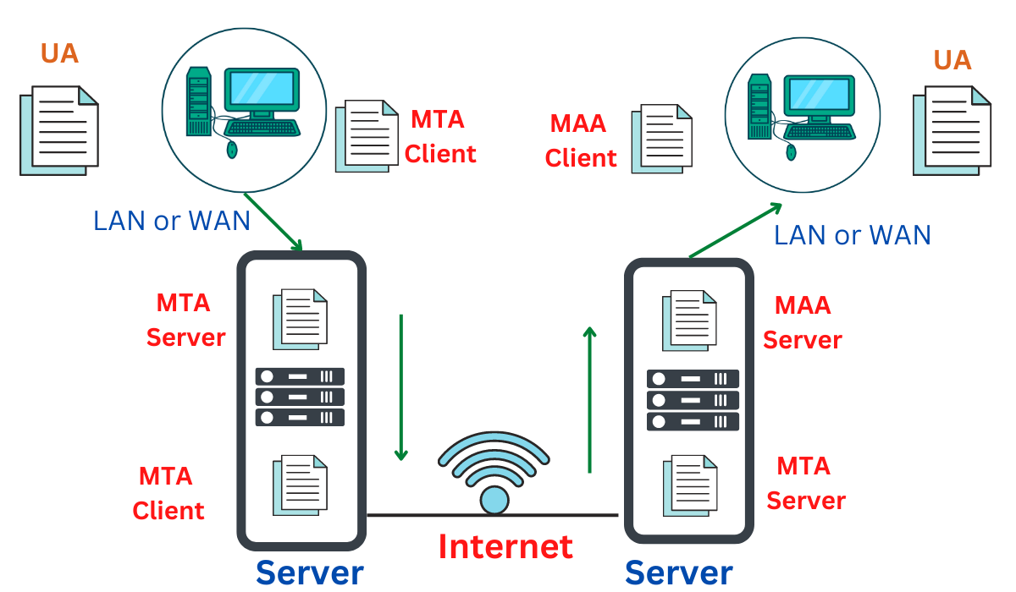

**Electronic mail, commonly known as email, is a method of exchanging messages over the internet. Here are the basics of email:**

1. An email address: This is a unique identifier for each user, typically in the format of name@domain.com.
2. An email client: This is a software program used to send, receive and manage emails, such as Gmail, Outlook, or Apple Mail.
3. An email server: This is a computer system responsible for storing and forwarding emails to their intended recipients.

**To send an email:**

1. Compose a new message in your email client.
2. Enter the recipient’s email address in the “To” field.
3. Add a subject line to summarize the content of the message.
4. Write the body of the message.
5. Attach any relevant files if needed.
6. Click “Send” to deliver the message to the recipient’s email server.
7. Emails can also include features such as cc (carbon copy) and bcc (blind carbon copy) to send copies of the message to multiple recipients, and reply, reply all, and forward options to manage the conversation.

**Electronic Mail** (e-mail) is one of most widely used services of [Internet](https://www.geeksforgeeks.org/the-internet-and-the-web/). This service allows an Internet user to send a **message in formatted manner (mail)** to the other Internet user in any part of world. Message in mail not only contain text, but it also contains images, audio and videos data. The person who is sending mail is called **sender** and person who receives mail is called**recipient**. It is just like postal mail service. **Components of E-Mail System :** The basic components of an email system are : User Agent (UA), Message Transfer Agent (MTA), Mail Box, and Spool file. These are explained as following below.

1. **User Agent (UA) :** The UA is normally a program which is used to send and receive mail. Sometimes, it is called as mail reader. It accepts variety of commands for composing, receiving and replying to messages as well as for manipulation of the mailboxes.
2. **Message Transfer Agent (MTA) :** MTA is actually responsible for transfer of mail from one system to another. To send a mail, a system must have client MTA and system MTA. It transfer mail to mailboxes of recipients if they are connected in the same machine. It delivers mail to peer MTA if destination mailbox is in another machine. The delivery from one MTA to another MTA is done by [Simple Mail Transfer Protocol](https://www.geeksforgeeks.org/simple-mail-transfer-protocol-smtp/).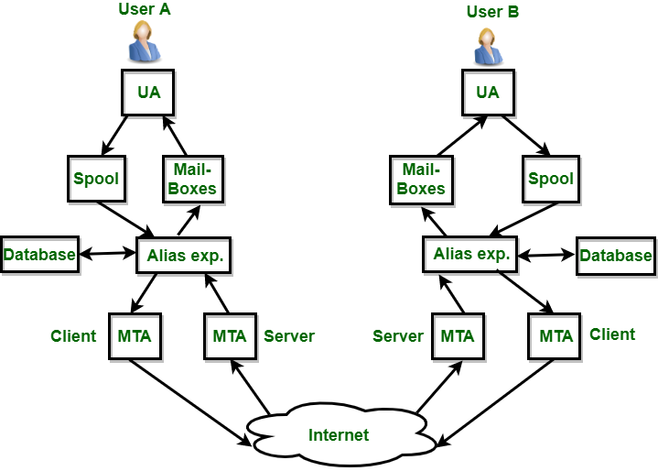
3. **Mailbox :** It is a file on local hard drive to collect mails. Delivered mails are present in this file. The user can read it delete it according to his/her requirement. To use e-mail system each user must have a mailbox . Access to mailbox is only to owner of mailbox.
4. **Spool file :** This file contains mails that are to be sent. User agent appends outgoing mails in this file using SMTP. MTA extracts pending mail from spool file for their delivery. E-mail allows one name, an **alias**, to represent several different e-mail addresses. It is known as **mailing list**, Whenever user have to sent a message, system checks recipient’s name against alias database. If mailing list is present for defined alias, separate messages, one for each entry in the list, must be prepared and handed to MTA. If for defined alias, there is no such mailing list is present, name itself becomes naming address and a single message is delivered to mail transfer entity.

**Services provided by E-mail system :**

* **Composition –** The composition refer to process that creates messages and answers. For composition any kind of text editor can be used.
* **Transfer –** Transfer means sending procedure of mail i.e. from the sender to recipient.
* **Reporting –** Reporting refers to confirmation for delivery of mail. It help user to check whether their mail is delivered, lost or rejected.
* **Displaying –** It refers to present mail in form that is understand by the user.
* **Disposition –** This step concern with recipient that what will recipient do after receiving mail i.e save mail, delete before reading or delete after reading.

**Advantages Or Disadvantages:  
Advantages of email:**

1. Convenient and fast communication with individuals or groups globally.
2. Easy to store and search for past messages.
3. Ability to send and receive attachments such as documents, images, and videos.
4. Cost-effective compared to traditional mail and fax.
5. Available 24/7.

**Disadvantages of email:**

1. Risk of spam and phishing attacks.
2. Overwhelming amount of emails can lead to information overload.
3. Can lead to decreased face-to-face communication and loss of personal touch.
4. Potential for miscommunication due to lack of tone and body language in written messages.
5. Technical issues, such as server outages, can disrupt email service.
6. It is important to use email responsibly and effectively, for example, by keeping the subject line clear and concise, using proper etiquette, and protecting against security threats.

Whether you're preparing for your first job interview or aiming to upskill in this ever-evolving tech landscape, [GeeksforGeeks Courses](https://www.geeksforgeeks.org/courses?utm_source=geeksforgeeks&utm_medium=article_bottom_text&utm_campaign=courses" \t "_blank) are your key to success. We provide top-quality content at affordable prices, all geared towards accelerating your growth in a time-bound manner. Join the millions we've already empowered, and we're here to do the same for you. Don't miss out - [check it out now](https://www.geeksforgeeks.org/courses?utm_source=geeksforgeeks&utm_medium=article_bottom_text&utm_campaign=courses)!

# **FTP**

* FTP stands for File transfer protocol.
* FTP is a standard internet protocol provided by TCP/IP used for transmitting the files from one host to another.
* It is mainly used for transferring the web page files from their creator to the computer that acts as a server for other computers on the internet.
* It is also used for downloading the files to computer from other servers.

## Objectives of FTP

* It provides the sharing of files.
* It is used to encourage the use of remote computers.
* It transfers the data more reliably and efficiently.

## Why FTP?

Although transferring files from one system to another is very simple and straightforward, but sometimes it can cause problems. For example, two systems may have different file conventions. Two systems may have different ways to represent text and data. Two systems may have different directory structures. FTP protocol overcomes these problems by establishing two connections between hosts. One connection is used for data transfer, and another connection is used for the control connection.

## Mechanism of FTP

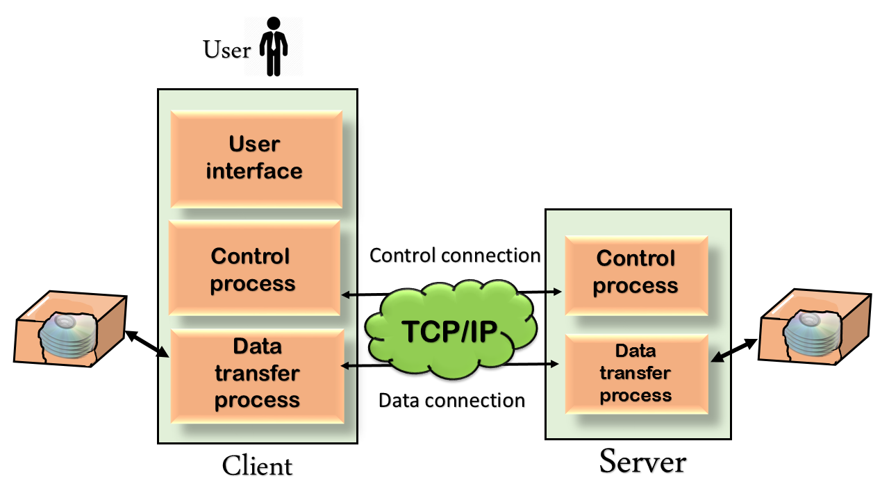

The above figure shows the basic model of the FTP. The FTP client has three components: the user interface, control process, and data transfer process. The server has two components: the server control process and the server data transfer process.

**There are two types of connections in FTP:**

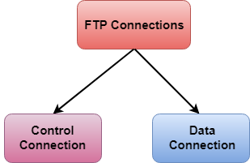

* **Control Connection:** The control connection uses very simple rules for communication. Through control connection, we can transfer a line of command or line of response at a time. The control connection is made between the control processes. The control connection remains connected during the entire interactive FTP session.
* **Data Connection:** The Data Connection uses very complex rules as data types may vary. The data connection is made between data transfer processes. The data connection opens when a command comes for transferring the files and closes when the file is transferred.

## FTP Clients

* FTP client is a program that implements a file transfer protocol which allows you to transfer files between two hosts on the internet.
* It allows a user to connect to a remote host and upload or download the files.
* It has a set of commands that we can use to connect to a host, transfer the files between you and your host and close the connection.
* The FTP program is also available as a built-in component in a Web browser. This GUI based FTP client makes the file transfer very easy and also does not require to remember the FTP commands.

### Advantages of FTP:

* **Speed:** One of the biggest advantages of FTP is speed. The FTP is one of the fastest way to transfer the files from one computer to another computer.
* **Efficient:** It is more efficient as we do not need to complete all the operations to get the entire file.
* **Security:** To access the FTP server, we need to login with the username and password. Therefore, we can say that FTP is more secure.
* **Back & forth movement:** FTP allows us to transfer the files back and forth. Suppose you are a manager of the company, you send some information to all the employees, and they all send information back on the same server.

### Disadvantages of FTP:

* The standard requirement of the industry is that all the FTP transmissions should be encrypted. However, not all the FTP providers are equal and not all the providers offer encryption. So, we will have to look out for the FTP providers that provides encryption.
* FTP serves two operations, i.e., to send and receive large files on a network. However, the size limit of the file is 2GB that can be sent. It also doesn't allow you to run simultaneous transfers to multiple receivers.
* Passwords and file contents are sent in clear text that allows unwanted eavesdropping. So, it is quite possible that attackers can carry out the brute force attack by trying to guess the FTP password.
* It is not compatible with every system.

# **What are the functions of Network Management**

Network Management involves monitoring and controlling a network system so that it can operate properly without downtime. So, the function performed by a network management system are categorised as follows −

## Fault management

Fault management is the procedure of technology used to manage the administrator who prevents faults within a networked system so that the availability of downtime is reduced by identifying, isolating and fixing any malfunctions that occur. It can support active and passive components to disavow fault.

## Configuration management

It refers to the process of initially configuring a network and then adjusting it in response to changing networks requirements. This function is important because improper configuration may cause the network to work suboptimal or may not work at all.

The configuration involves the parameters at the network interface like IP address, DHCP, DNS, server address etc.

## Network management

Network management is the procedure of maintaining and organizing the active and passive network elements. It will support the services to maintain network elements and network performance monitoring and management.

It recognises the fault, Investigate, Troubleshoot, Configuration Management and OS changes to fulfil all the user requirements. It allows computers in a network to communicate with each other, control networks and allow troubleshooting or performance enhancements.

## Data logging and report

Data logs record all the records and interactions that pass through a specific point in a system, between keyboard and display. If any system failure appears, the administrator can go to the log and view what might have created it.

## Accounting management of network resources

To keep a record of usage of network resources known as accounting management. Like to examine and to determine how to better allocate resources. One might examine the type of traffic or level of traffic at a particular port.

It can also monitor activities of users about password & user id and authentication for the usage of resources.

## Performance Management

It involves monitoring network utilization, end to end response time & performance of resources at various points in a network. For example, to keep track of switched interfaces in an Ethernet.

## Network Security

It refers to the process of providing security on network and network resources. It involves managing the security services on a resource by using access control, authentication, confidentiality, integrity and non-repudiation.

# **HTTP**

* HTTP stands for **HyperText Transfer Protocol**.
* It is a protocol used to access the data on the World Wide Web (www).
* The HTTP protocol can be used to transfer the data in the form of plain text, hypertext, audio, video, and so on.
* This protocol is known as HyperText Transfer Protocol because of its efficiency that allows us to use in a hypertext environment where there are rapid jumps from one document to another document.
* HTTP is similar to the FTP as it also transfers the files from one host to another host. But, HTTP is simpler than FTP as HTTP uses only one connection, i.e., no control connection to transfer the files.
* HTTP is used to carry the data in the form of MIME-like format.
* HTTP is similar to SMTP as the data is transferred between client and server. The HTTP differs from the SMTP in the way the messages are sent from the client to the server and from server to the client. SMTP messages are stored and forwarded while HTTP messages are delivered immediately.

## Features of HTTP:

* **Connectionless protocol:** HTTP is a connectionless protocol. HTTP client initiates a request and waits for a response from the server. When the server receives the request, the server processes the request and sends back the response to the HTTP client after which the client disconnects the connection. The connection between client and server exist only during the current request and response time only.
* **Media independent:** HTTP protocol is a media independent as data can be sent as long as both the client and server know how to handle the data content. It is required for both the client and server to specify the content type in MIME-type header.
* **Stateless:** HTTP is a stateless protocol as both the client and server know each other only during the current request. Due to this nature of the protocol, both the client and server do not retain the information between various requests of the web pages.

## HTTP Transactions

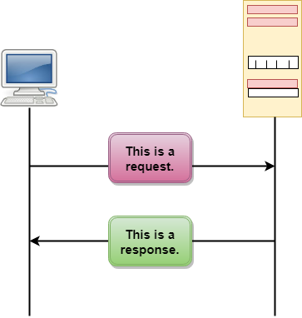

The above figure shows the HTTP transaction between client and server. The client initiates a transaction by sending a request message to the server. The server replies to the request message by sending a response message.

## Messages

HTTP messages are of two types: request and response. Both the message types follow the same message format.

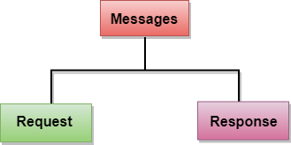

**Request Message:** The request message is sent by the client that consists of a request line, headers, and sometimes a body.

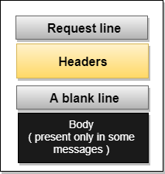

**Response Message:** The response message is sent by the server to the client that consists of a status line, headers, and sometimes a body.

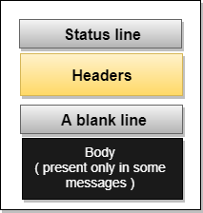

## Uniform Resource Locator (URL)

* A client that wants to access the document in an internet needs an address and to facilitate the access of documents, the HTTP uses the concept of Uniform Resource Locator (URL).
* The Uniform Resource Locator (URL) is a standard way of specifying any kind of information on the internet.
* The URL defines four parts: method, host computer, port, and path.

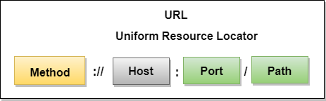

* **Method:** The method is the protocol used to retrieve the document from a server. For example, HTTP.
* **Host:** The host is the computer where the information is stored, and the computer is given an alias name. Web pages are mainly stored in the computers and the computers are given an alias name that begins with the characters "www". This field is not mandatory.
* **Port:** The URL can also contain the port number of the server, but it's an optional field. If the port number is included, then it must come between the host and path and it should be separated from the host by a colon.
* **Path:** Path is the pathname of the file where the information is stored. The path itself contain slashes that separate the directories from the subdirectories and files.